**Class Diagram**

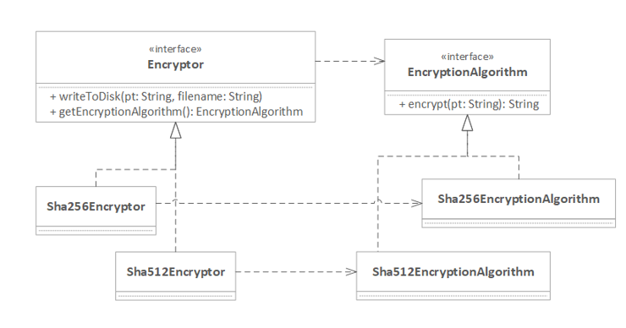

**Mapping**

Abstract Factory -> Encryptor

Concrete Factory -> Sha256Encryptor, Sha512Encryptor

Product ->EncryptionAlgorithm

Concrete Product -> Sha256EncryptorAlgorithm, Sha512EncryptorAlgorithm